**Governor Stirling Senior High School**

**Year 12 Physics**

**Task 3: Test 2 – Gravity, Satellites and Static Equilibrium**

**Gravity, Satellites and Static Equilibrium**

**NAME**: _______________________________________

**TEACHER**:_______________________ **MARKS**: **/45**

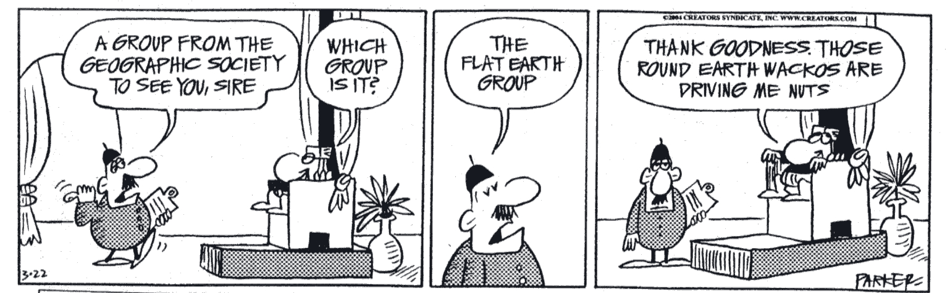

* **Answer all 8 questions.**
* **When calculating numerical answers, show all working including formulae.**
* **Give final answers to three significant figures and include appropriate units.**
* **When estimating numerical answers, show your working or reasoning clearly. Give final answers to a maximum of two significant figures and include appropriate units.**

1. The Mars Odyssey spacecraft was launched from Earth on 7 April 2001 and arrived at Mars on 23 October 2001. While in deep space, on the way to Mars, Odyssey was travelling at a constant velocity of 23 000 m s–1 and the spacecraft and all its contents were weightless. Explain why an object inside the spacecraft could be described as weightless. (2 marks)

________________________________________________________________________________________________________________________________________________________________________________________________________________________________________________________________________________________________

1. A 670 kg robotic spaceship is sitting on the surface of Venus which has a mass of 4.867 x 1024 kg and an average radius of 6051.8 km.
2. Calculate the gravitational force acting on the robotic space ship while on the surface of Venus. (3 marks)
3. Use this information to determine the magnitude of the gravitational field strength on the surface of Venus. (2 marks)

c. High above the planet Venus is the robot’s Mother ship, orbiting the planet. Derive a formula required to determine the orbital radius of the Mother ship using its time period. (3 marks)

1. The bridge over an irrigation channel is shown in the figure below. The bridge can be considered as a uniform concrete beam of length 30.0 m and mass 20.0 tonnes. A heavily loaded small truck of mass 6.00 tonnes is pictured crossing the bridge.

Calculate the magnitude of each of the normal contact forces N1 and N2 at each end of the bridge when the centre of mass of the truck is 10.0 m from one end.

(5 marks)



1. A satellite orbits 4.22 x 107 m above the Earth’s centre. At a certain point in its orbit around the Earth, the satellite and the Moon line up as shown in the diagram below. Show that in this position the gravitational influence of the Moon on the satellite is negligible, compared with the influence of the Earth. (7 marks)



1. A communication satellite having a mass of 2.10 x 104 kg orbits the Earth.
2. Determine the orbital radius for this satellite. (2 marks)

1. What is the magnitude of the orbital velocity for this satellite? (2 marks)

c. List one important use of communication satellites. (1 mark)

___________________________________________________________________________________________________________________________________________________________________________________________________________________________

d. When a satellite is launched it is placed in an initial circular orbit around the Earth. Later some small jets on board the satellite will fire compressed gas for a set period of time to move it to the precise final circular orbit required. These gas jets point backward relative to the satellite’s motion only and not toward or away from the Earth.

How can backward facing gas jets be used to raise the satellite to a higher final circular orbit? (3 marks)

______________________________________________________________________________________________________________________________________________________________________________________________________________________________________________________________________________________________________________________________________________________________________________________________________________________________________________________

6. A forest walk in Tasmania consists of an elevated steel walkway high above the ground. A uniform walkway has been constructed so that people can walk out over a river. It is designed to support a load of 10 000 kg and is 24.0 m long. A single steel cable supports the walkway, attached 8.00 m from the end at 50o as shown in the figure below. The walkway has a mass of 7.00 x 102 kg.

If the walkway is uniform and the maximum load of 10 000 kg is distributed evenly over the entire section, explain whether the cable will hold if the maximum tension the cable can withstand before breaking is 1.50 x 105 N. Support your answer with calculations.

(3 marks)



7. The graph below shows the relation between the gravitational field strength experienced by a 1.00 kg mass at various orbital heights above the Earth’s surface. Use the area under the curve to calculate the approximate energy needed to take a 400 kg spacecraft from rest at the surface of the Earth and place it in a stable circular orbit of height 1.70 × 106 m, travelling at 7.00 x 103 m s-1. (3 marks)



8. A uniform ladder of mass 40.0 kg and length 10.0 m leans against a smooth vertical wall. A person of mass 80.0 kg stands on the ladder at a distance 7.00 m from the bottom, as measured along the ladder. The foot of the ladder is 1.20 m from the bottom of the wall.

(i) What is the force exerted by the wall on the ladder? (4 marks)

(ii) What is the reaction force exerted by the floor on the ladder? (4 marks)